Nama : Gede Satyamahinsa Prastita Uttama

NIM : 1203220054

Kelas : IF-02-03

**TUGAS REKURSIF**

1. Source Code

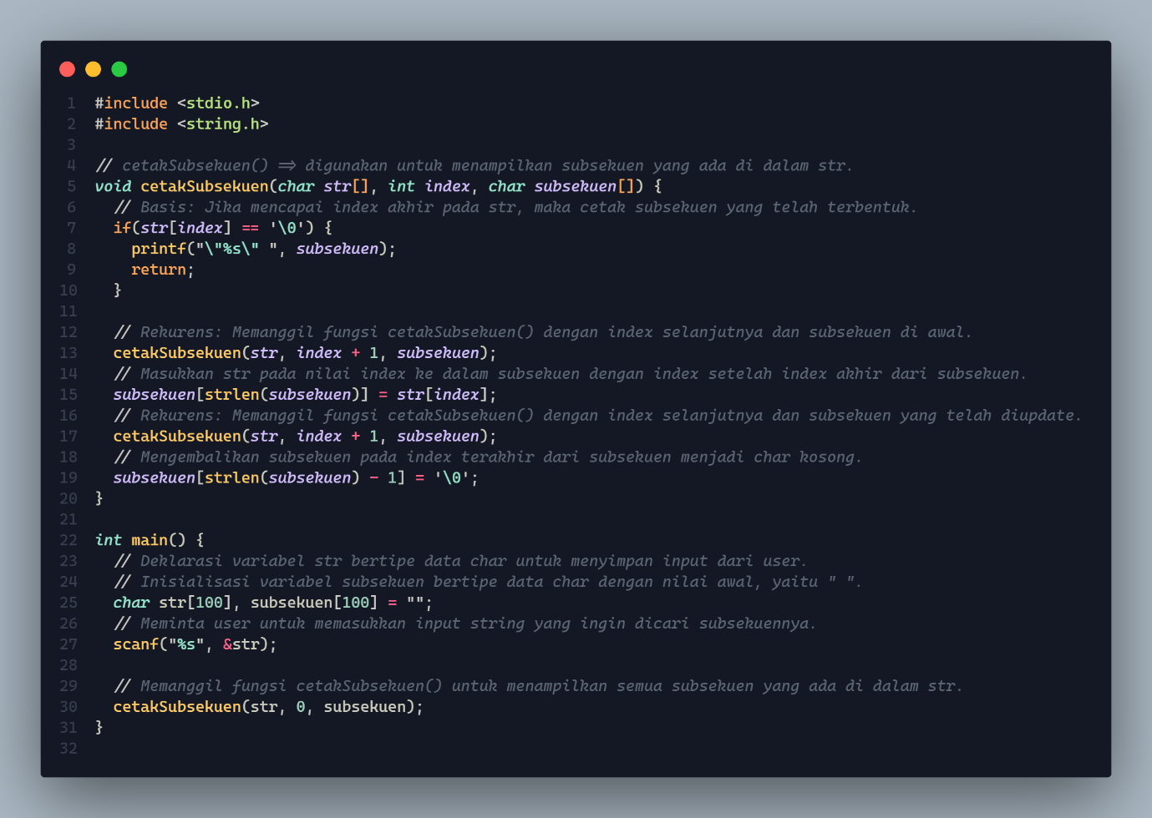

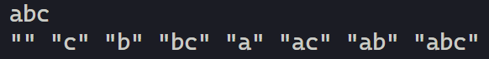Output



1. 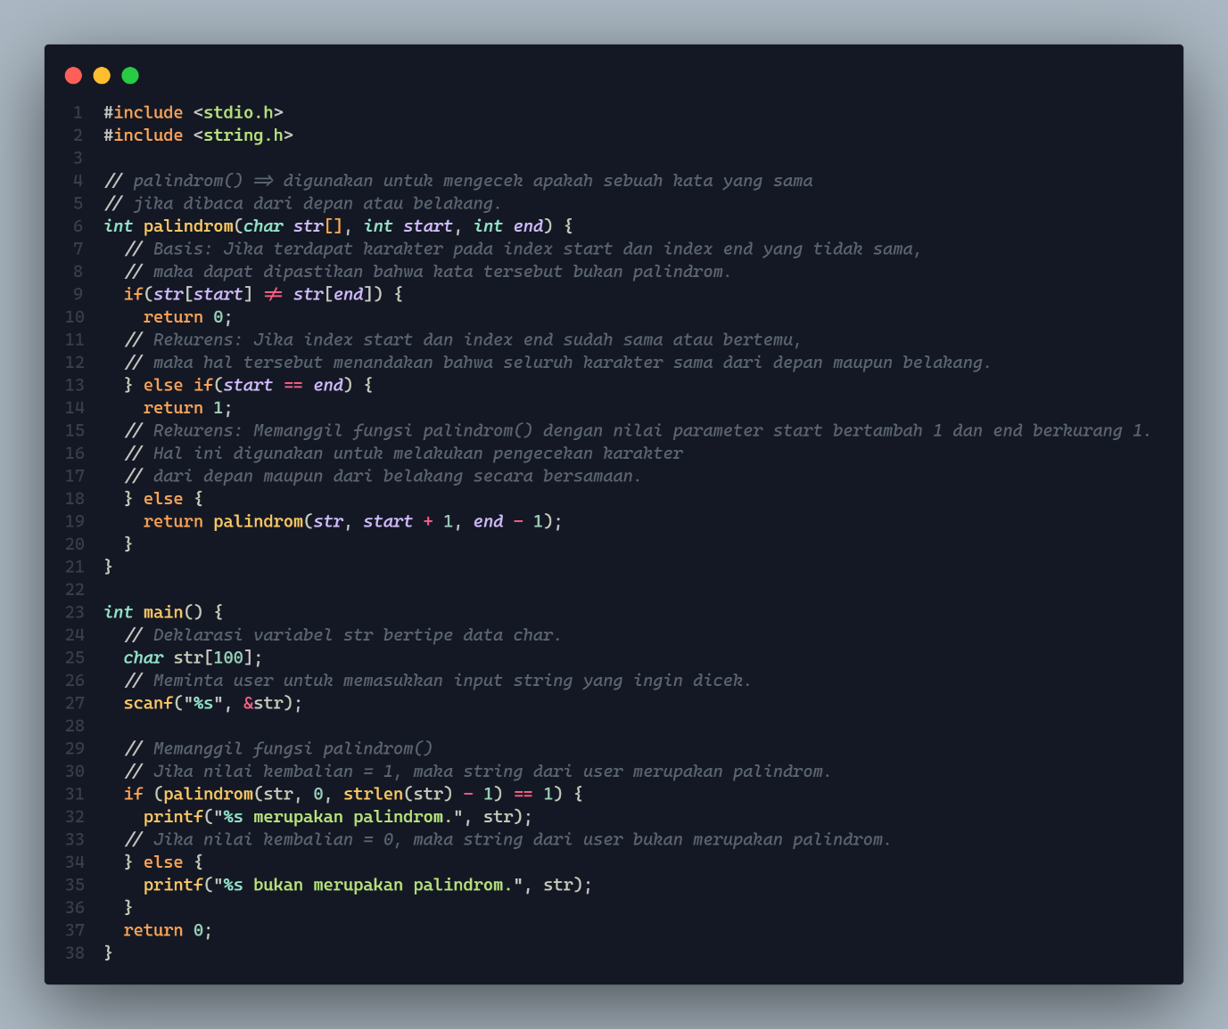Source Code

Output



1. 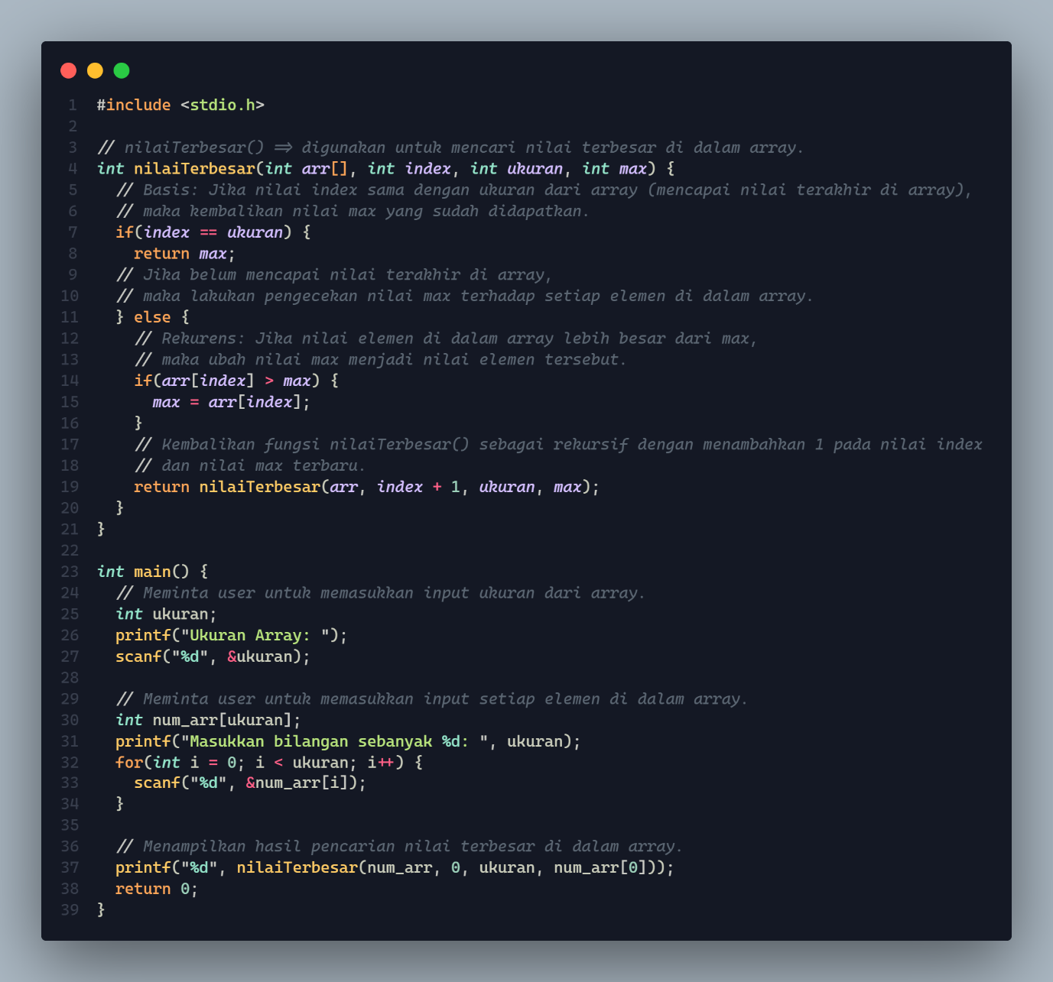Source Code

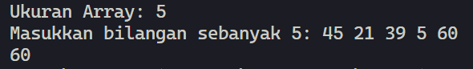Output

1. 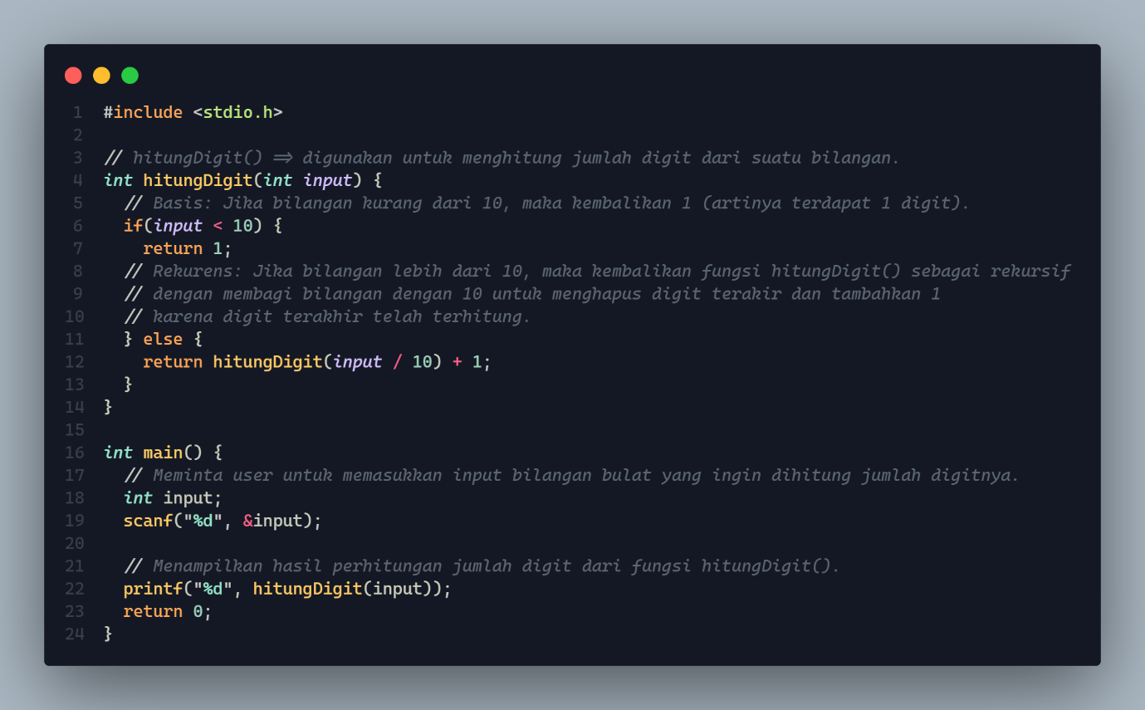Source Code

Output

